Name: BHOOMIKA S USN: 4NI25EC403 Date:3-03-2026

Experiment 2

Aim:
To design and simulate the 3 Amplifier configurations
Simulation Tool: LTspice

Technology: tsmc 180nm

Components Required:

Component Name | Value / Model
Resistor | 15K
NMOS | W = 390nm L = 180nm
DC Voltage (Supply) | 1.8 V
Voltage Source | Signal: Sinusoidal  Amplitude: 1 V  Frequency: 1 kHz  AC amplitude = 1 V
Component Name | Value / Model
Resistor | 15K
PMOS | W = 923nm L = 180nm
DC Voltage (Supply) | 1.8 V
Voltage Source | Signal: Sinusoidal  Amplitude: 1 V  Frequency: 1 kHz  AC amplitude = 1 V

Schematic Circuit:

1.

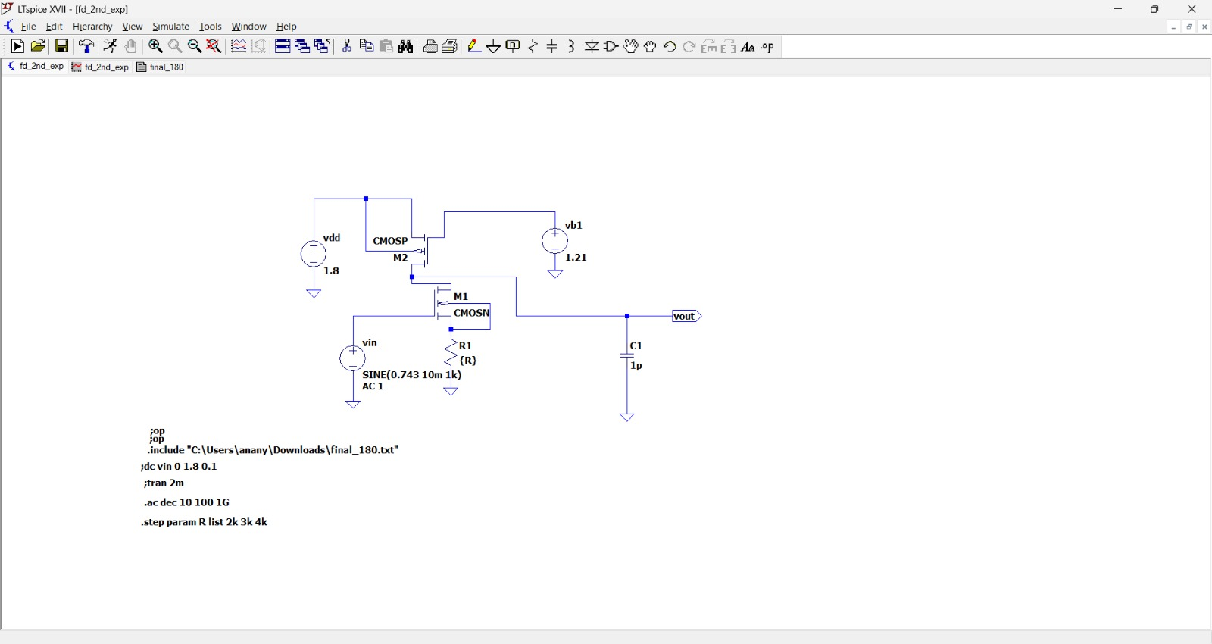

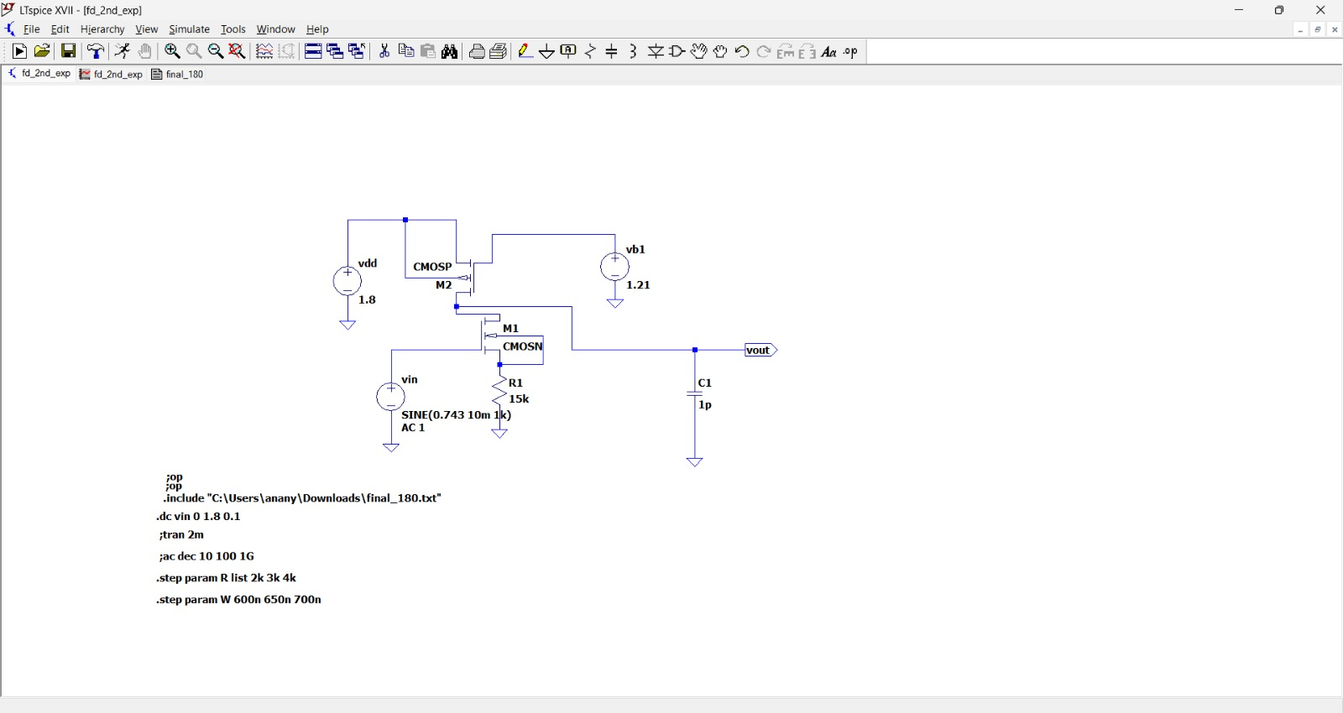
2.

3.

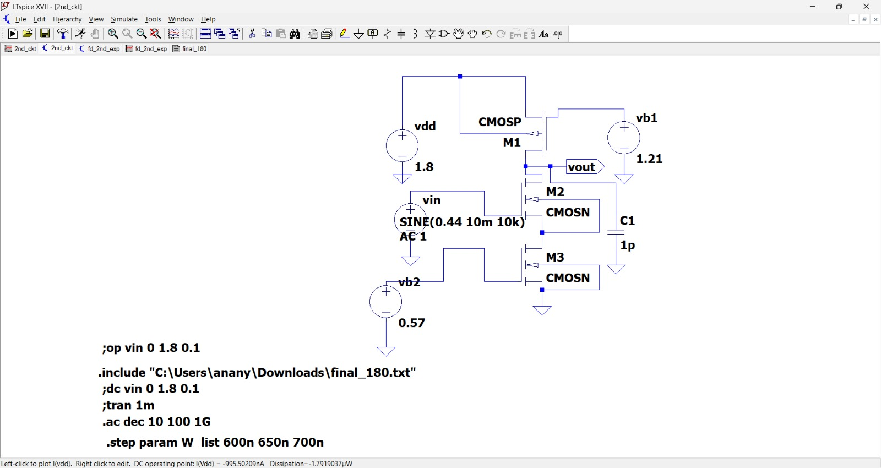

Design:

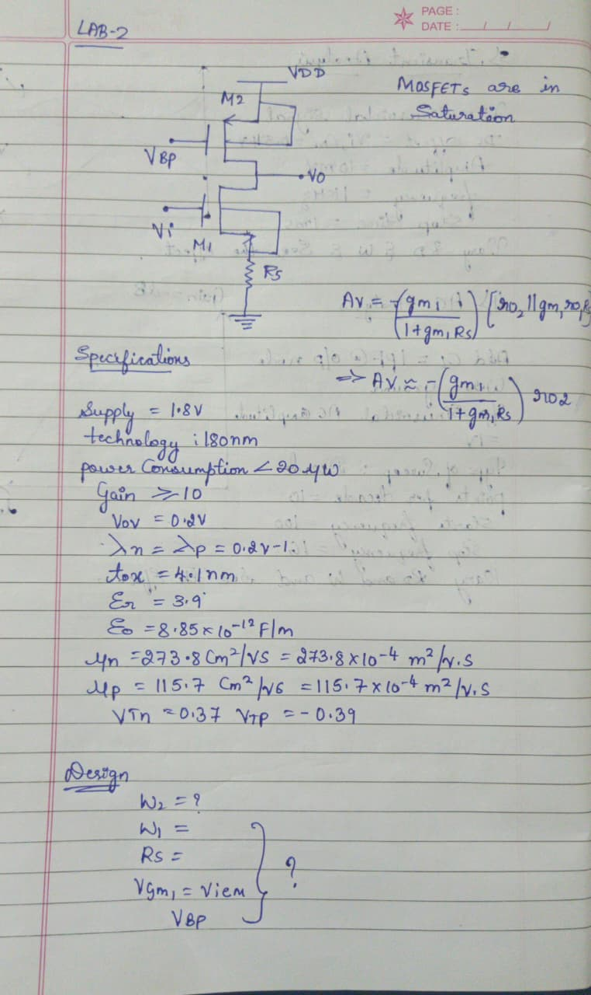

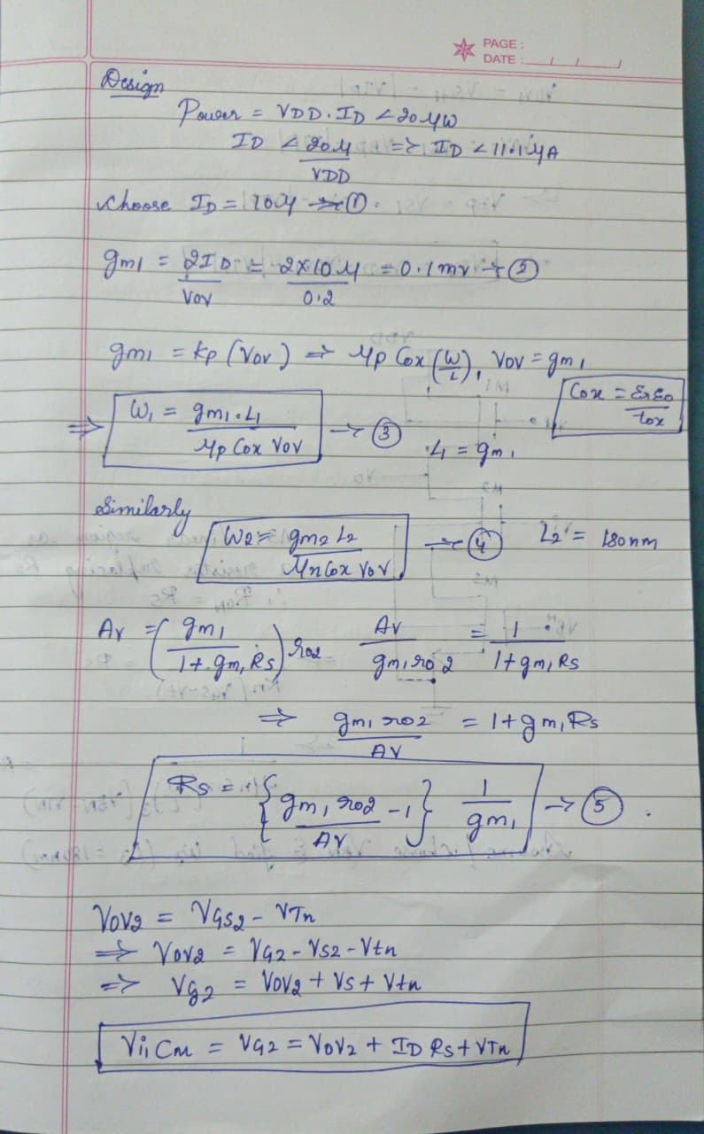

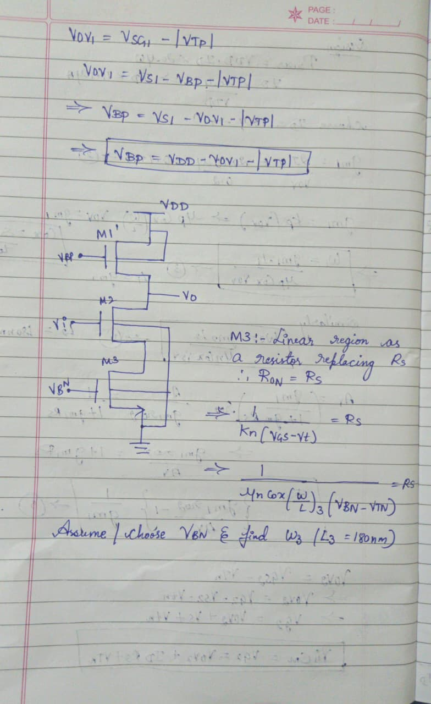

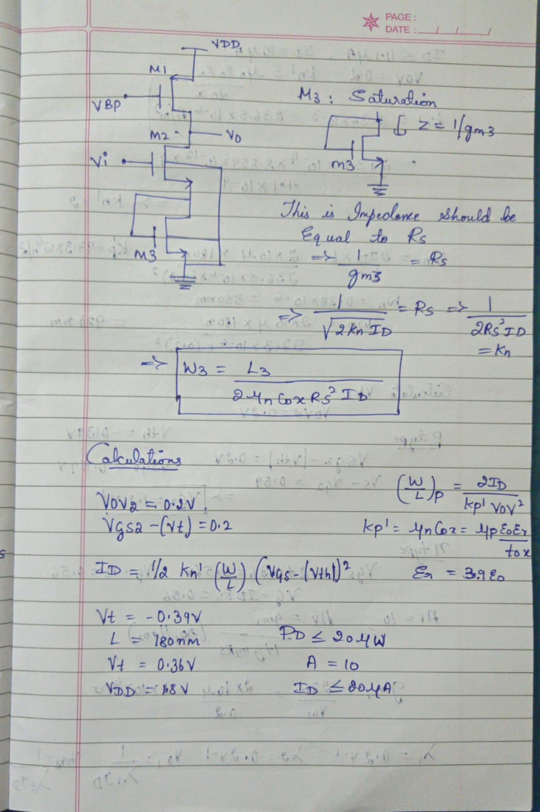

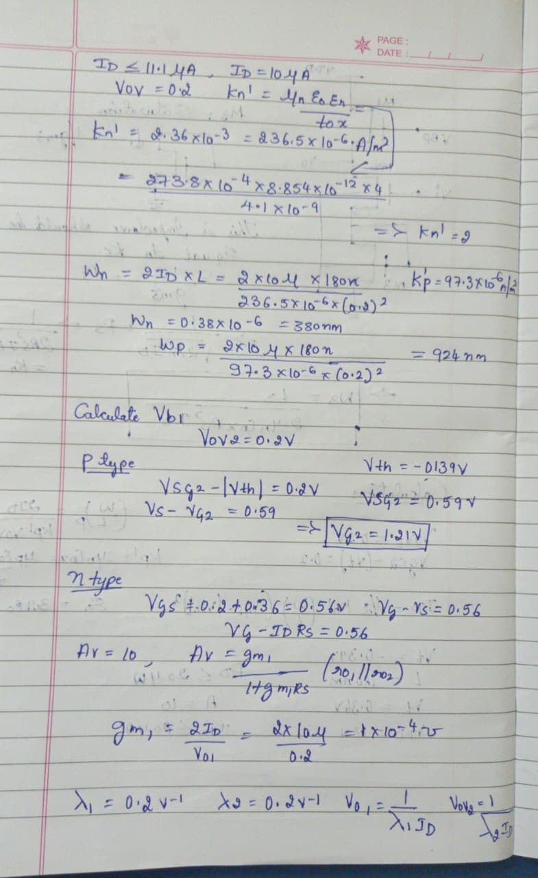

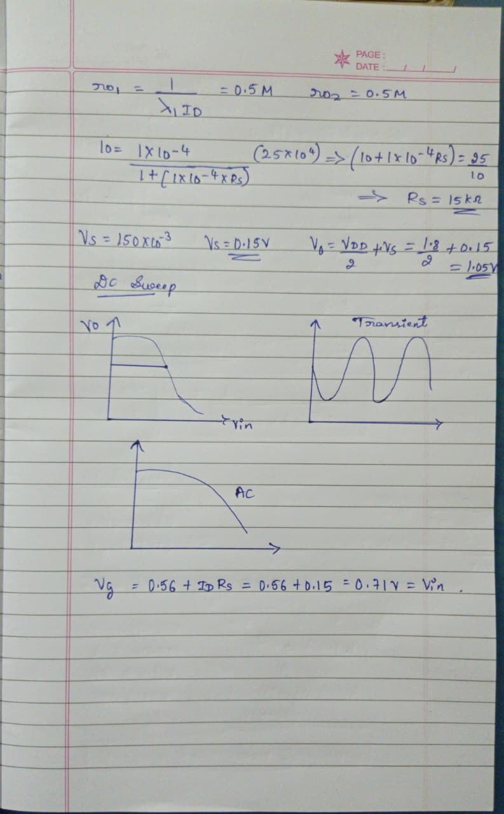
Simulation Results:
- DC Analysis:
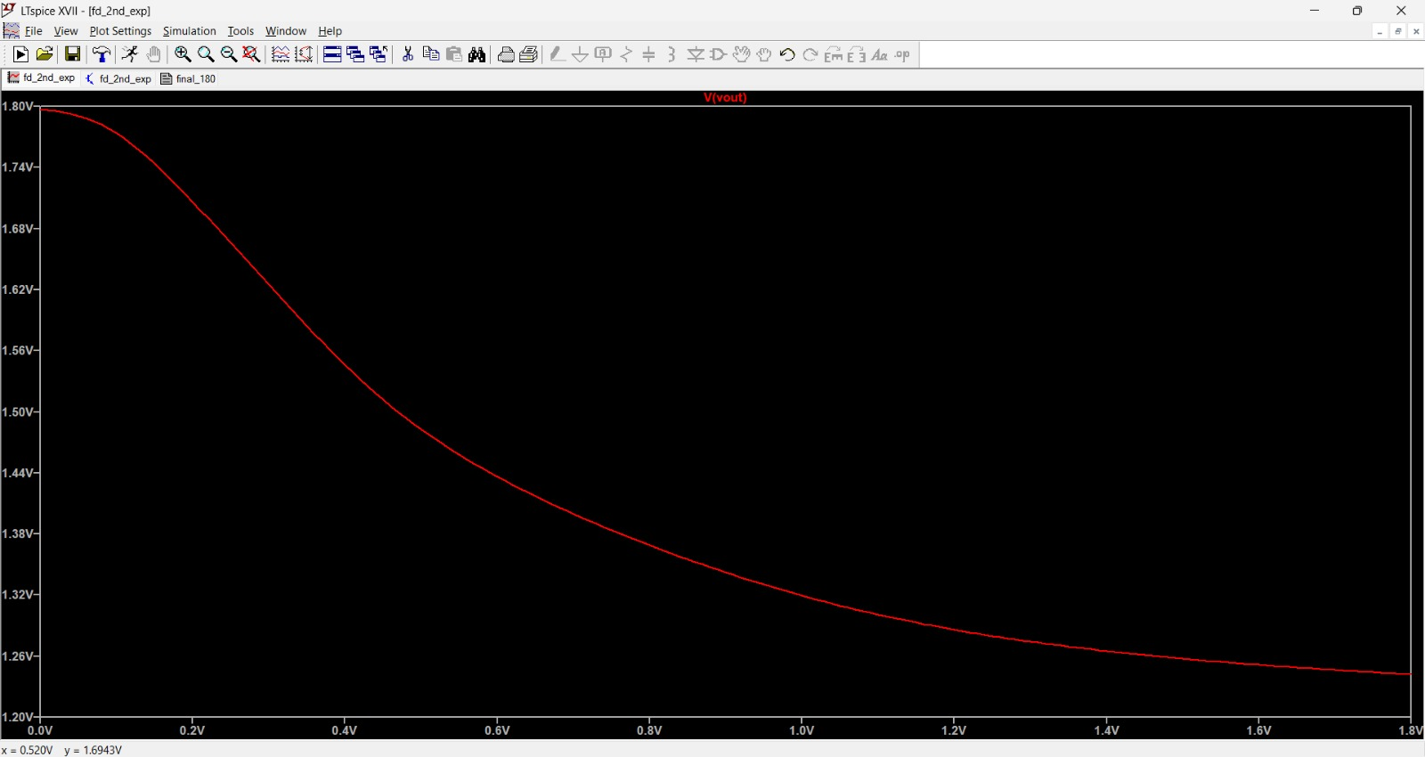
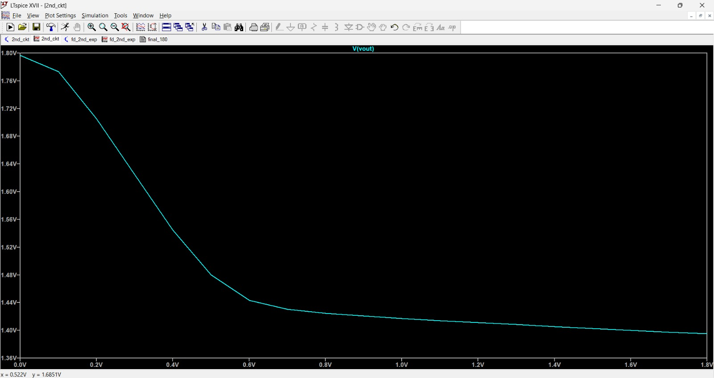

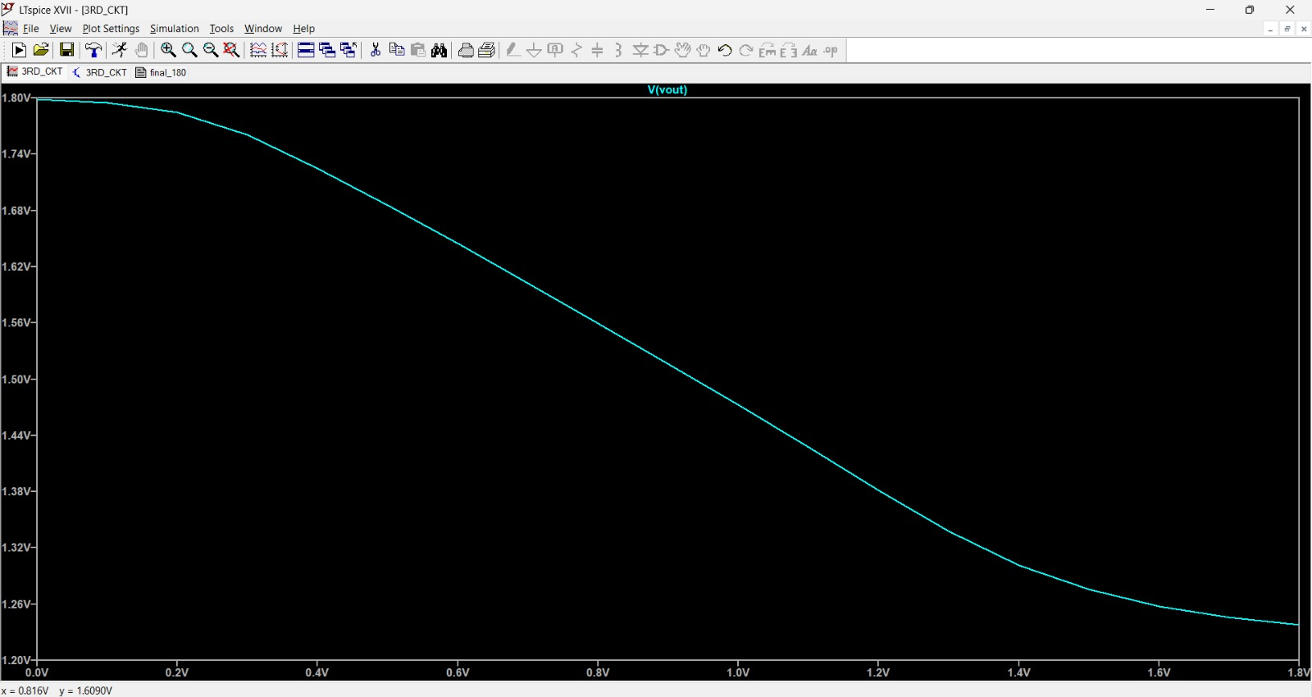

B) Transient Analysis:

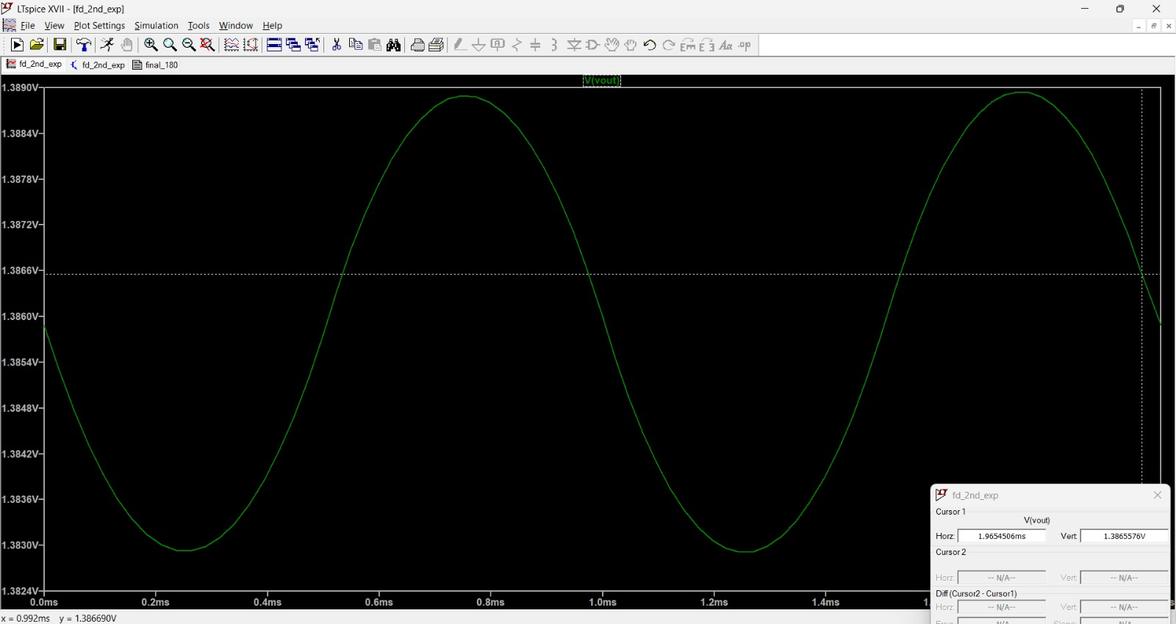
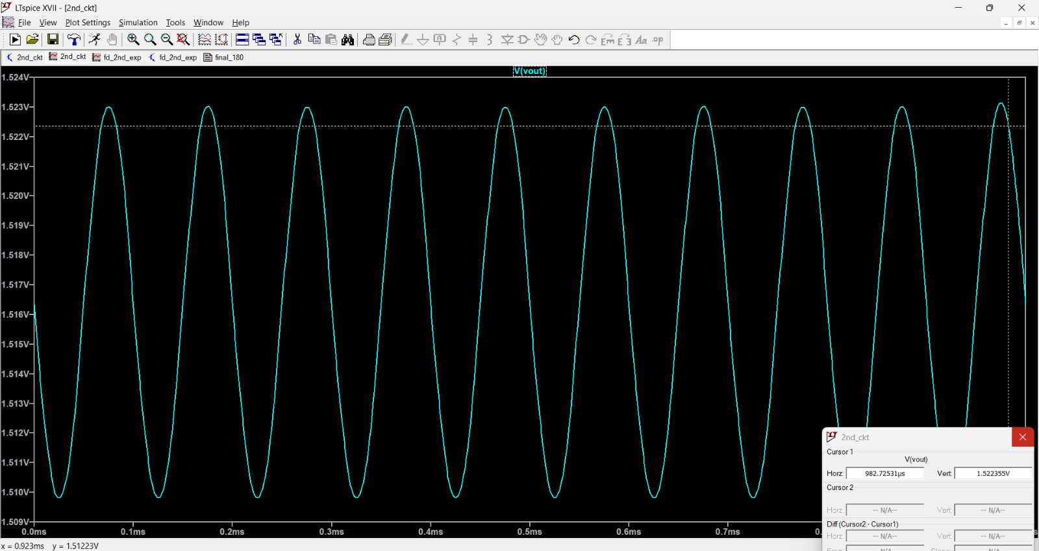



EFFECT OF VARYING R

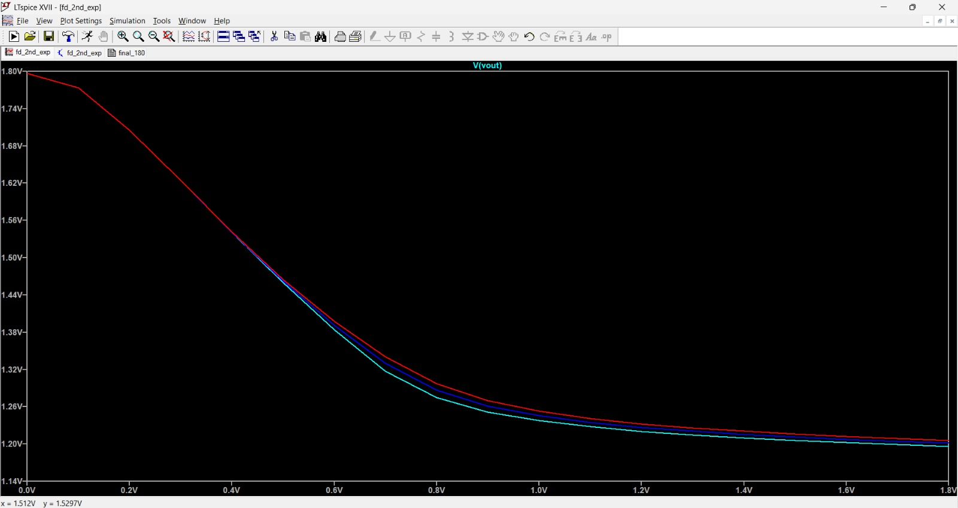

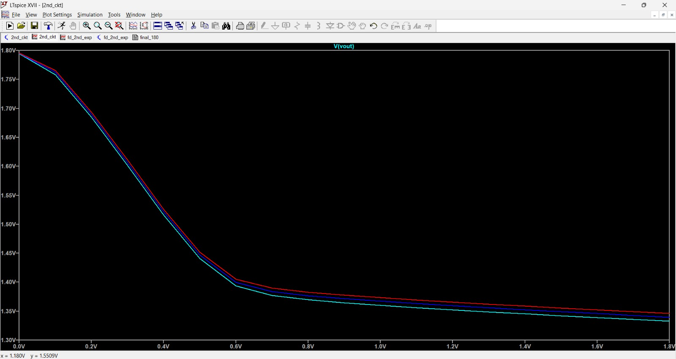

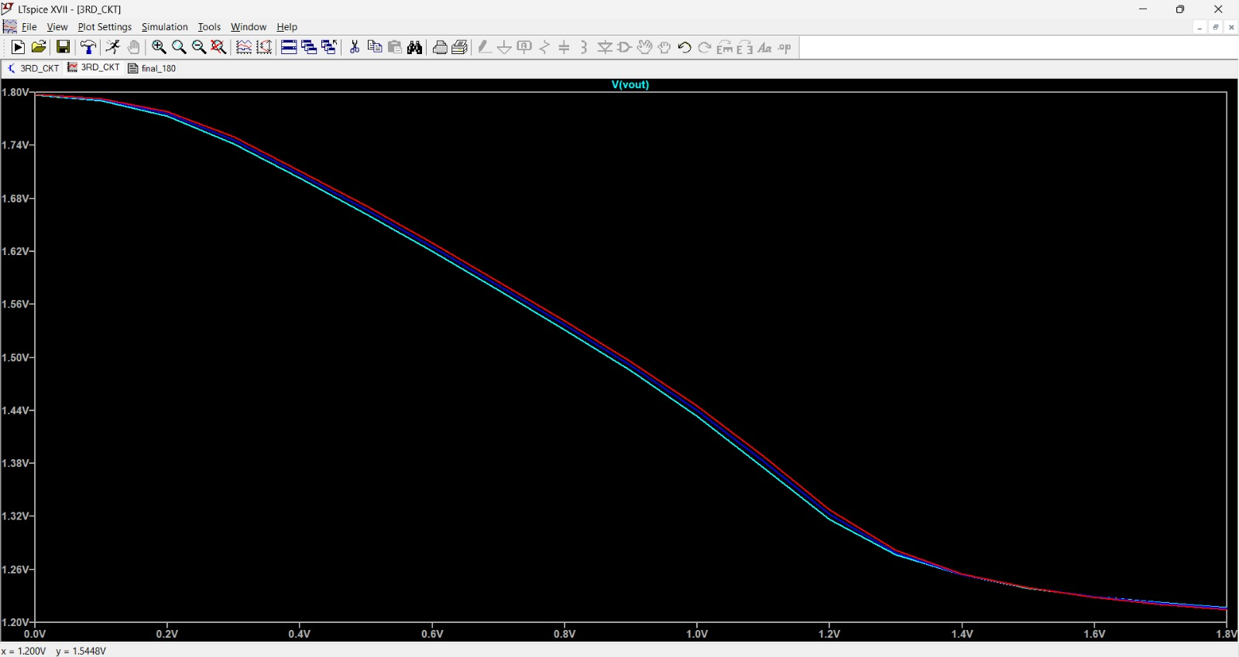


DC SWEEP
TRANSIENT
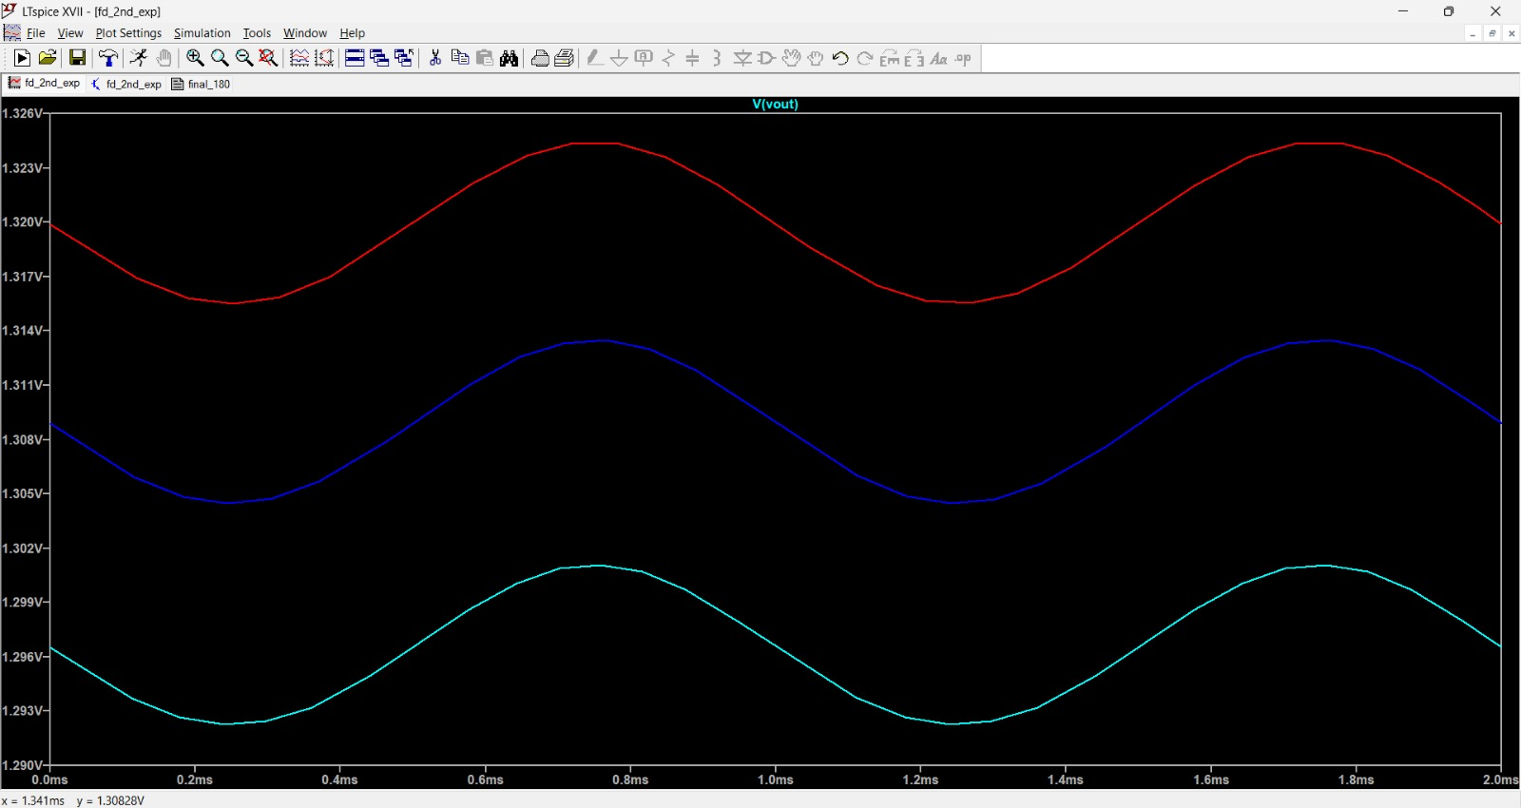

C) AC Analysis:
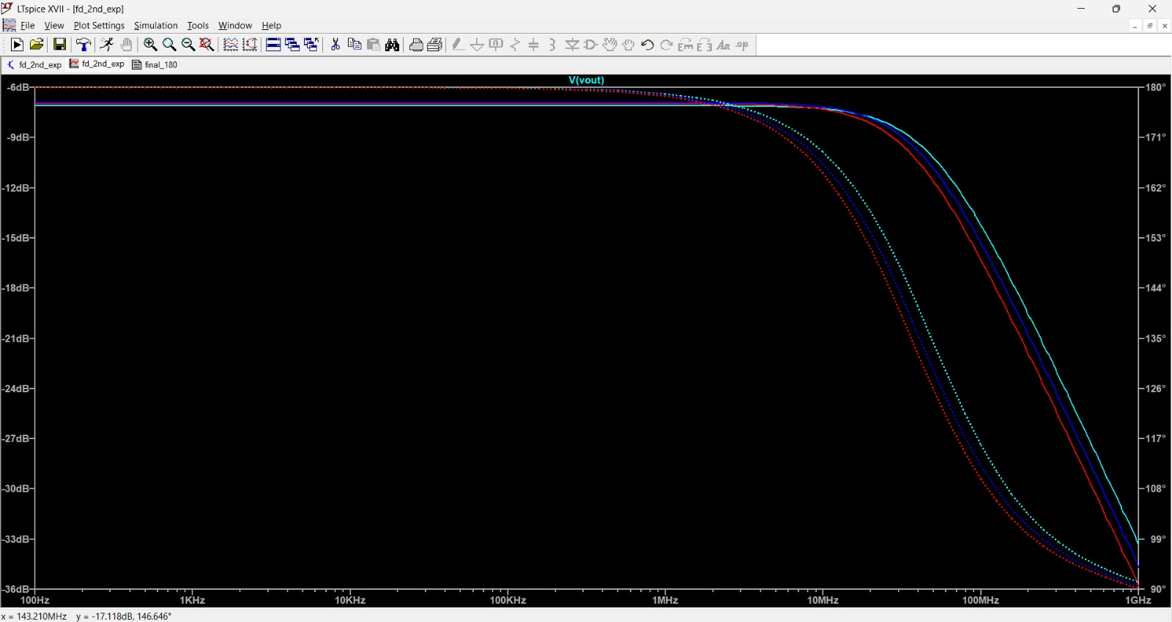



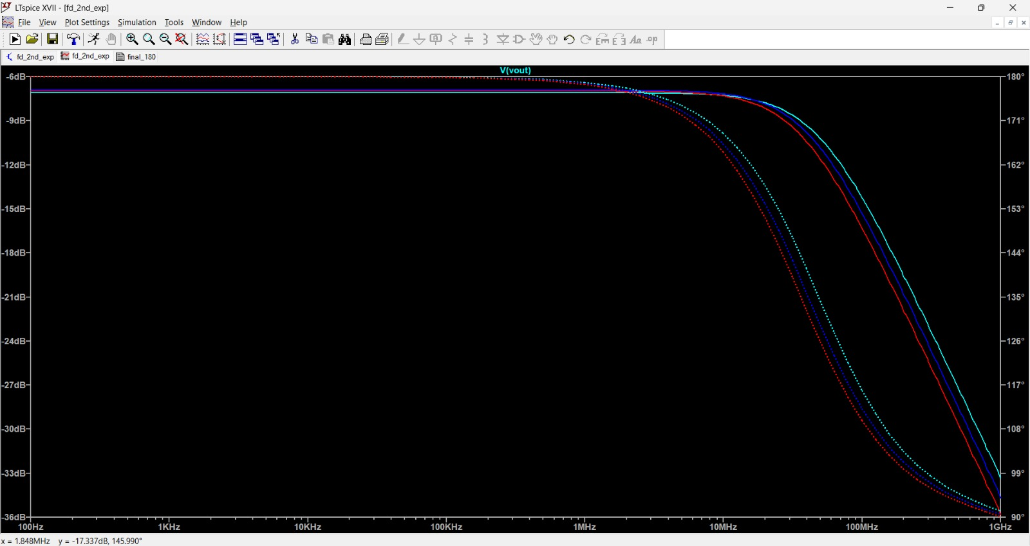

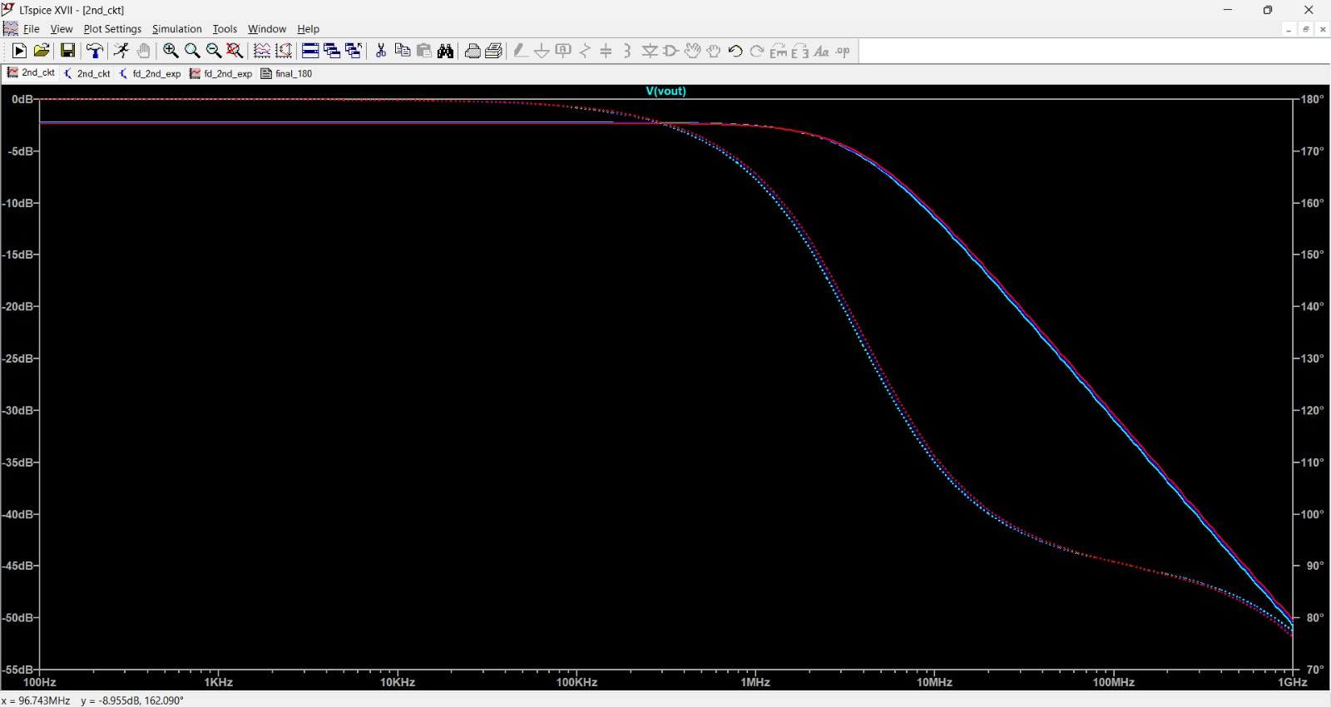



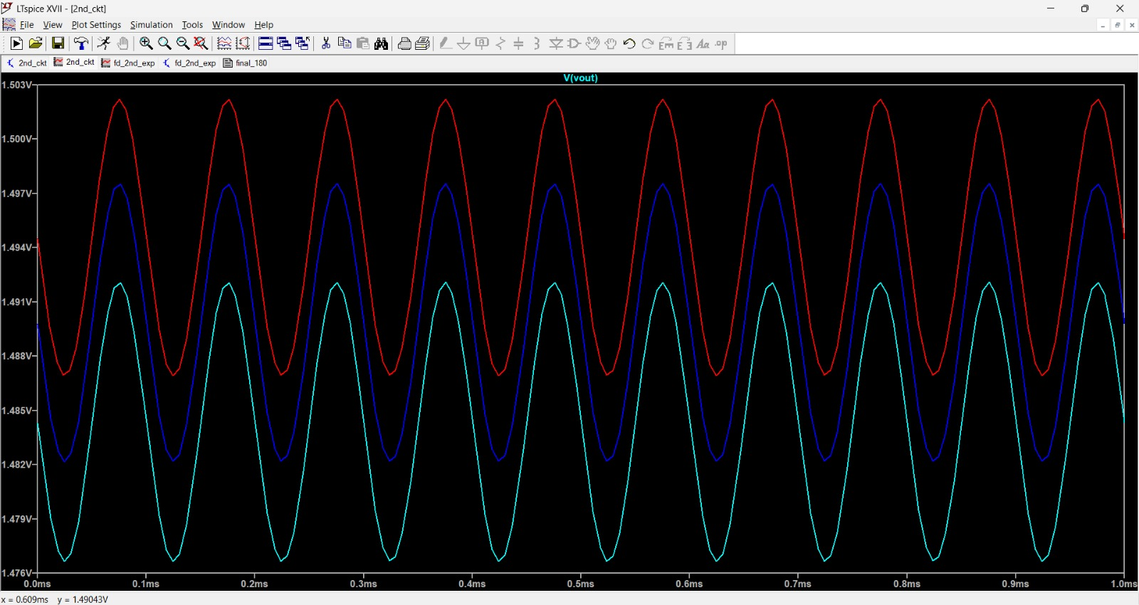
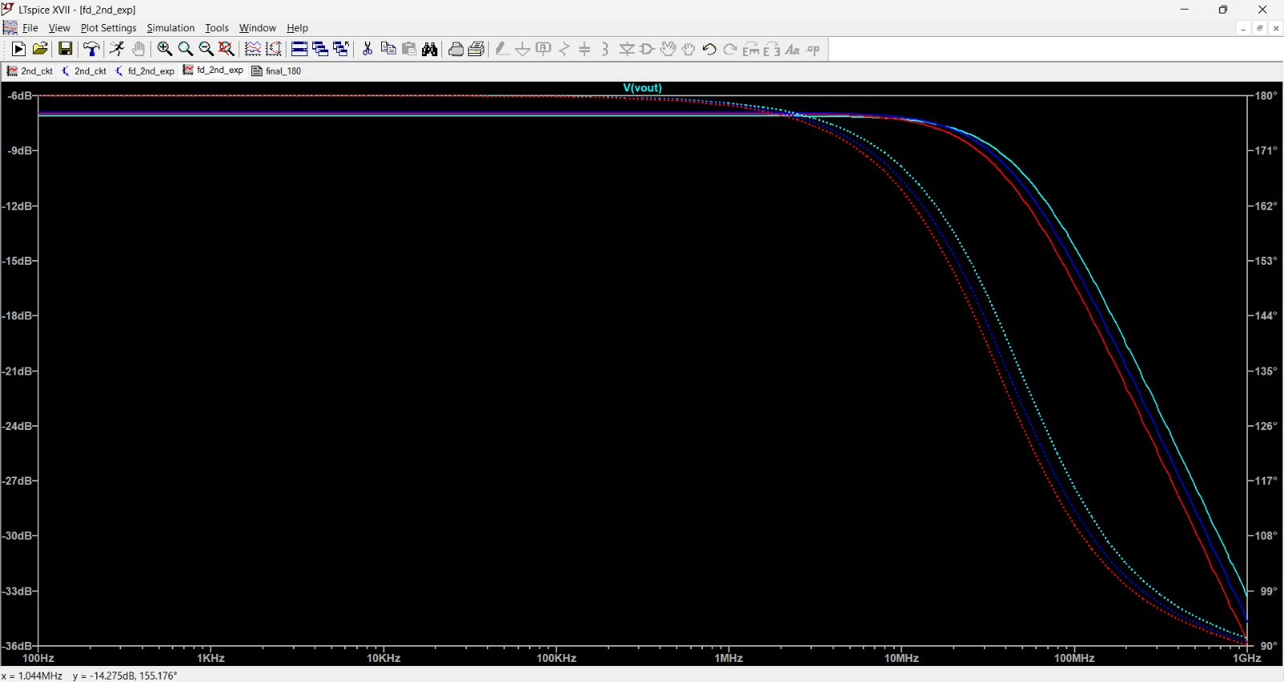

Effect of varying R_{D} Effect of varying W

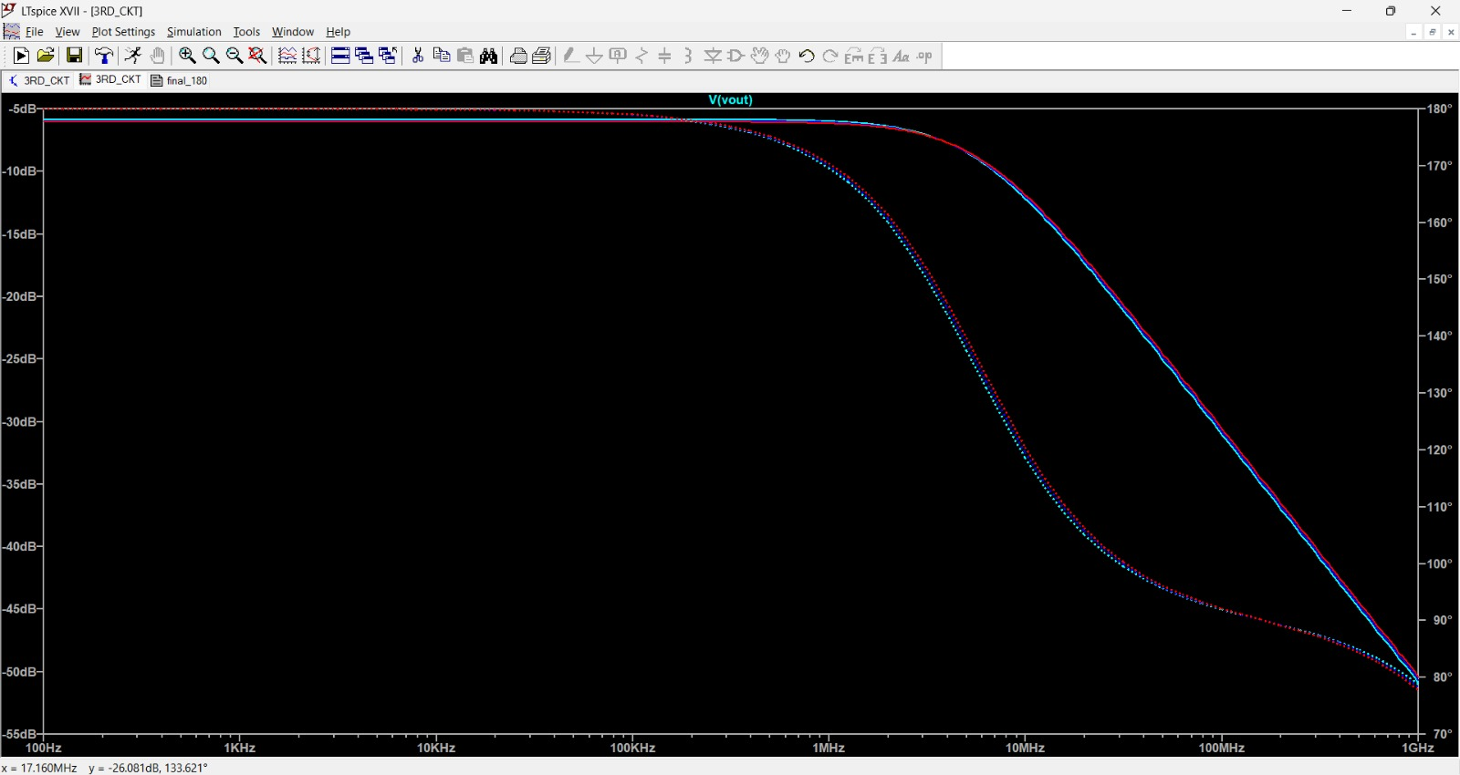





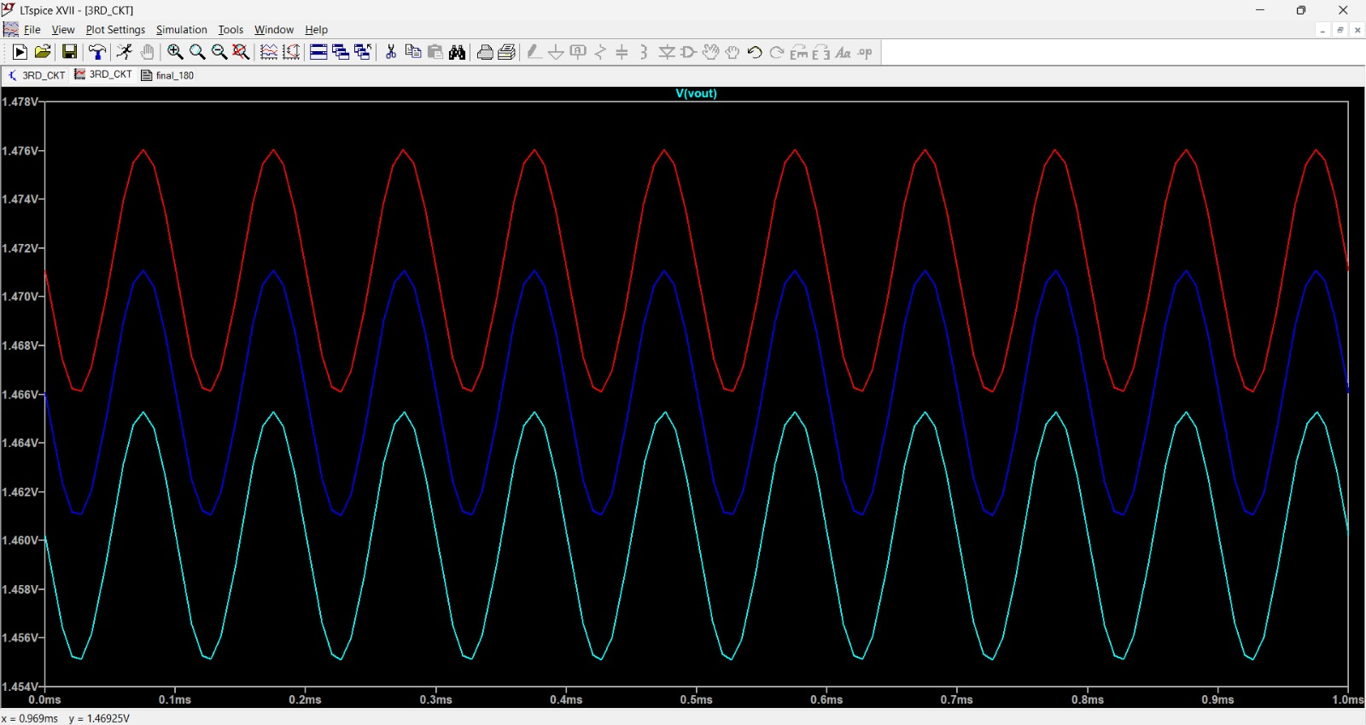

Inference:
The Common Source (CS) amplifier using NMOS and PMOS shows high voltage gain with 180° phase inversion, confirming the fundamental behavior of a CS configuration.
From DC Analysis:
The operating point (Q-point) was established in the saturation region, ensuring proper amplification.
Drain current increases with increase in ratio.
Proper biasing ensures maximum symmetrical swing.
From Transient Analysis:
The output waveform is inverted with respect to input.
Increasing increases voltage gain but reduces output swing margin.
Larger increases drain current and improves transconductance , thereby increasing gain.
Excessive increase in pushes the transistor toward triode region.
From DC Sweep:
The transfer characteristic confirms three regions:
Cut-off
Saturation (amplification region)
Triode
Gain is maximum in saturation region.
From AC Analysis:
The amplifier shows high mid-band gain.
Gain increases with:
Increase in
Increase in transistor width
Bandwidth decreases as gain increases (Gain–Bandwidth trade-off).

Conclusion:
Common Source amplifier was successfully designed and simulated using 180nm CMOS technology in LTspice.
The following conclusions were observed:
The CS amplifier provides high voltage gain with 180° phase shift.
Proper biasing ensures operation in saturation region.
Gain increases with increase in drain resistance and transistor width.
There exists a trade-off between gain and bandwidth.
The experimental results closely match theoretical expectations.

Verified by:

Date:

